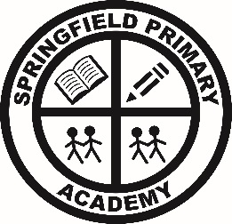

Care, Collaboration, Challenge
Person Specification: Class Teacher
Criteria | Qualities
Qualifications and experience | - Qualified teacher status  - Degree  - Successful primary teaching practice
Skills and Knowledge | - Knowledge of the National Curriculum  - Knowledge of effective teaching and learning strategies  - A good understanding of how children learn  - Ability to adapt teaching to meet pupils’ needs  - Ability to build effective working relationships with pupils  - Knowledge of guidance and requirements around safeguarding children  - Knowledge of effective behaviour management strategies  - Good ICT skills, particularly using ICT to support learning
Characteristics | - A commitment to getting the best outcomes for all pupils and promoting the ethos and values of the school  - High expectations for children’s attainment and progress  - Commitment to maintaining confidentiality at all times  - Commitment to safeguarding and equality  - Ability to develop good personal relationships within a team  - Ability to create a happy, challenging and effective learning environment  - Ability to communicate effectively, both orally and in writing  - A lively, creative and good-humoured approach to all aspects of teaching

